Applying OSG
PART 1: Preparing the data for analysis
(Make sure you open the osg file on a new Excel so you don’t have the text to column issue)

- Copy over three columns to a new tab: (INVOICE NUMBER), (AMOUNT), (SHORTPAY COMMENT)
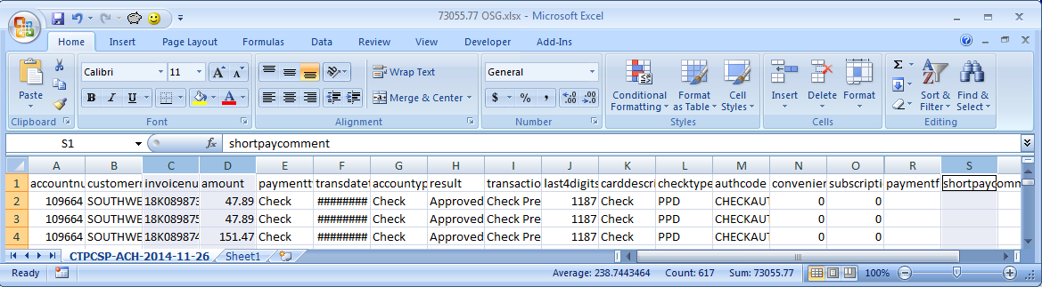

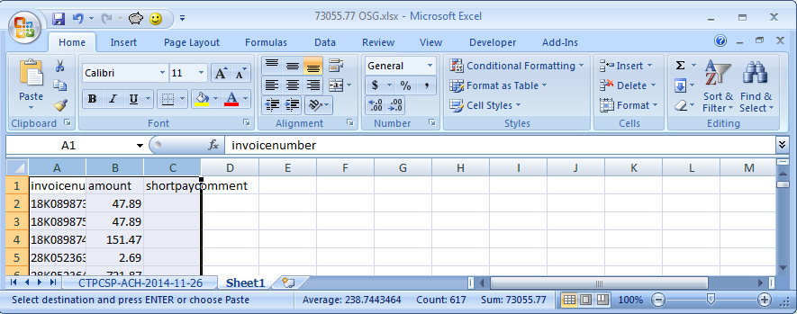
- Cut paste short pay (SHORT PAY COMMENT) to the first column and run invoice match on Access:
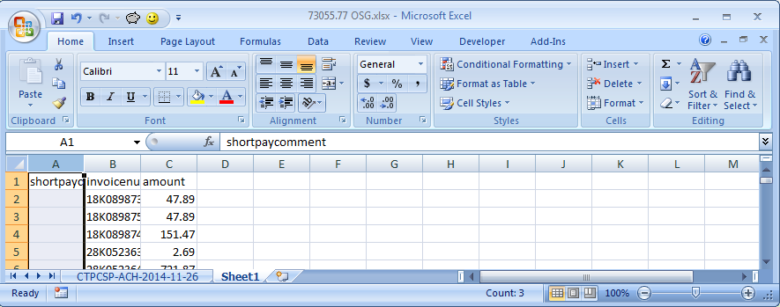
- Copy the invoice match result to that same Sheet 1 tab, and auto size all the column widths:
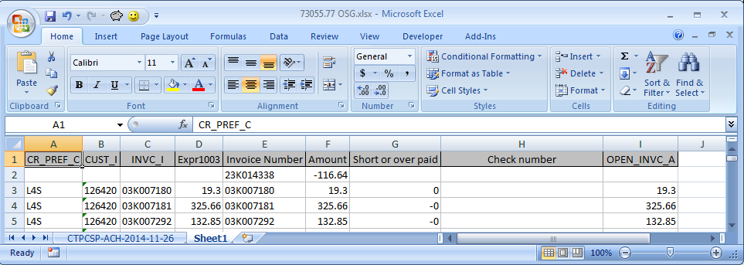

- You have to cut paste any/all invoices that weren’t found in Access to their own sheet (they have to be researched and applied separately with iq76 and ar21 and if needed, ar36 to reinstate). Sometimes the invoices not found are negative, like above, so make sure you also copy over a positive invoice with it so you can partially apply (the system doesn’t let you partially apply negative amounts to a positive check amount).
- Select all the columns, add a filter, and sort by the “Short or overpaid” column ascending:
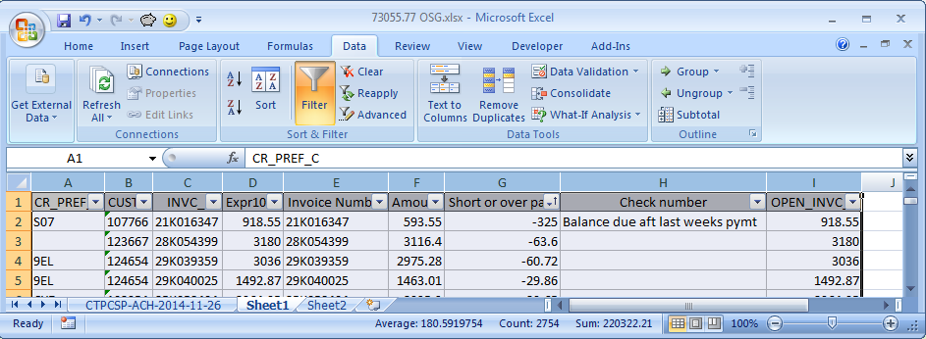

- Cut paste over all the rows that are short over paid by zero to their own tab on the second row:
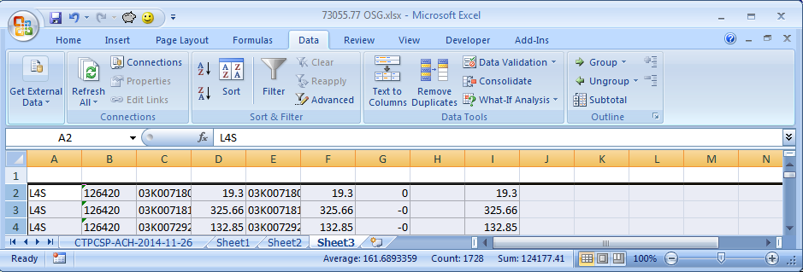

- (make sure you deleted those rows that were copied over from sheet1) Go back to sheet 1, sort by customer number ascending, and add the following formulas to cells J2 and K2. Double click them down the list (double click the little black square at the bottom right corner):
  - J2: =if(b1<>b2,1,0)
  - K2: =sum($j$2:J2)
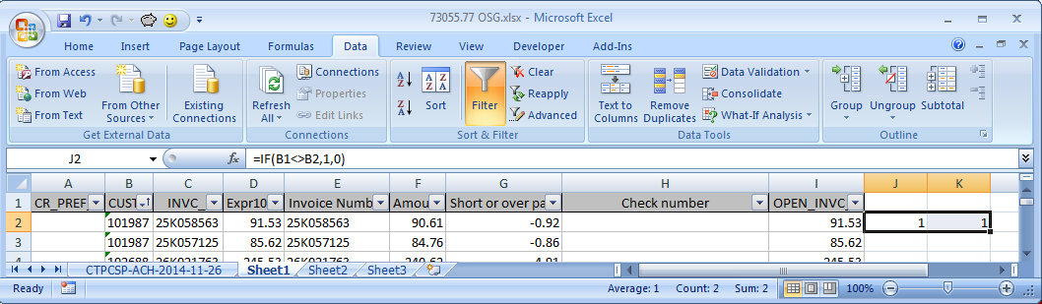
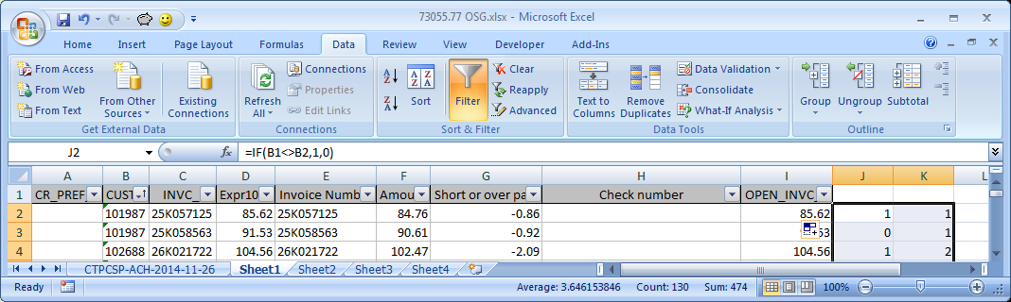

- Column K now has the customer number count, so you should cut paste so that you only have about 11 customers on the tab. Everything else is cut pasted into another tab:
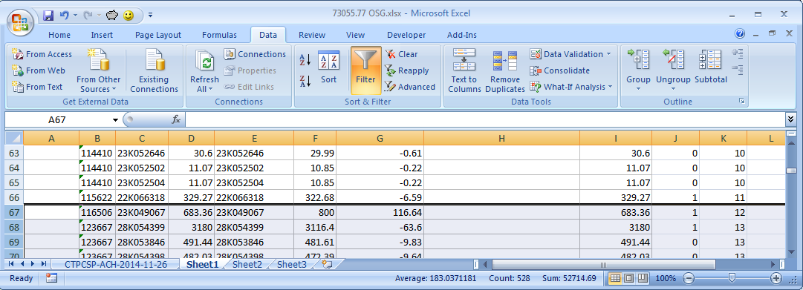

- Go back to Sheet1, sort by Invoice Number Ascending, delete columns J and K, and run the macro:
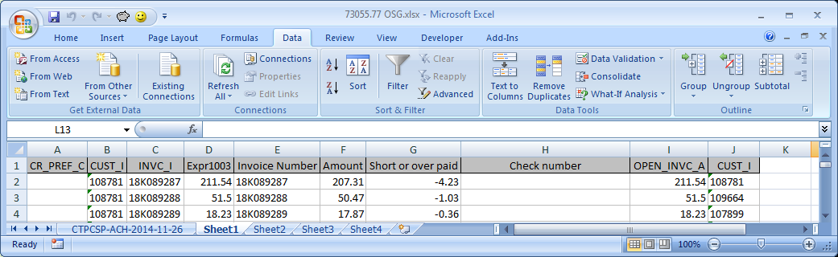
- Run the mainframe macro after adding the customer numbers.
- After the macro runs, Shift+F1 to see your selected invoices, copy over the first page of invoices from the invoice# to the discount as one big box copy to Sheet1 on cell L2:
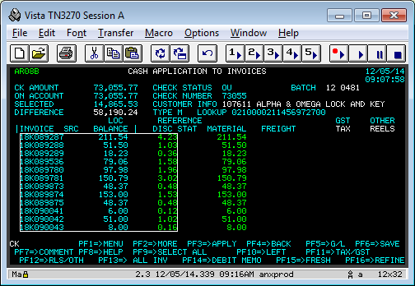
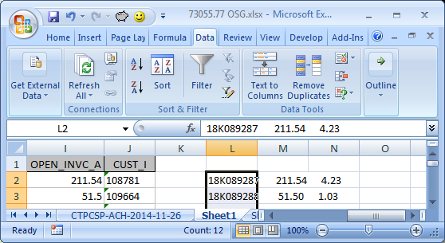
- Do Text to Columns to separate the data, Add the column Headers (Starting with cell L1):
  - Inv, Amt, Disc, Remit, Diff, Diff / Amt, Diff + Disc, Note, Match Found?
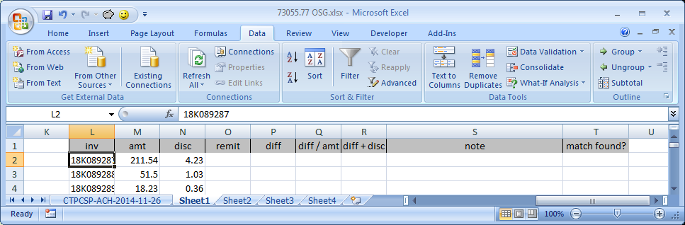

- Enter the following formulas between cells O2 through S2:
  - O2: =VLOOKUP(L2,$E:$F,2,FALSE)
  - P2: = O2-M2
  - Q2: = ROUND(100*P2/M2,2)
  - R2: = ROUND(P2+N2,2)
  - S2: =VLOOKUP(L2,$E:$H,4,FALSE)
- Select R2 and add Conditional Formatting -> Highlight Cell Rules By -> Equal To… and on the window that pops up, set the format cells value to 0 with Green Fill with Dark Green Text and click Ok:
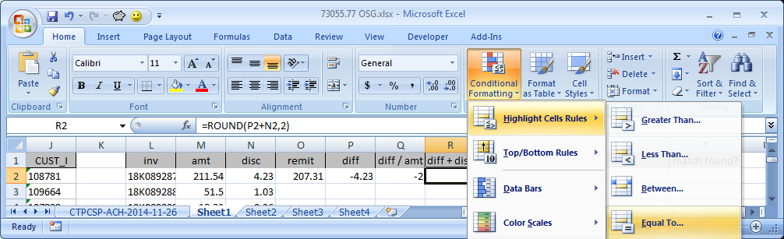
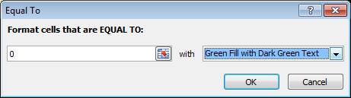

- Select cells O2through S2 and double click down the list:
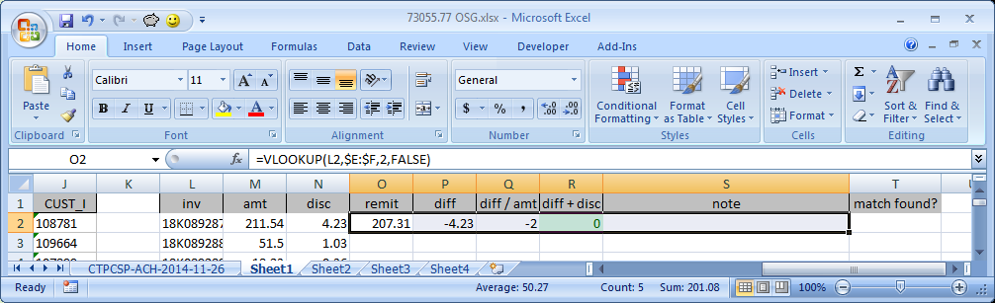
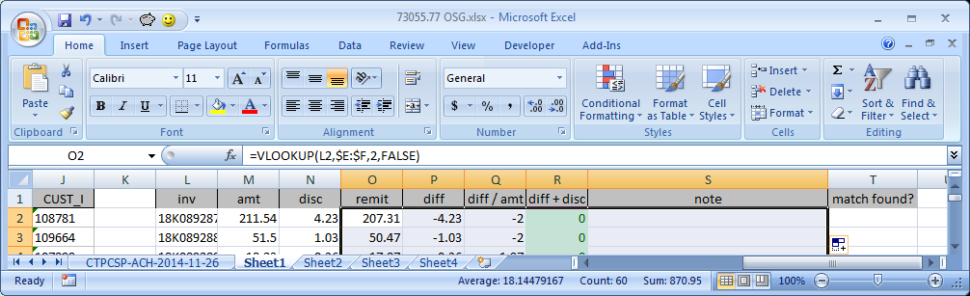

- Auto size column L, widen column S if you haven’t yet, select cells L1 through whatever the last cell on the T column is, go to the Insert Tab, and click Table. Then make sure the checkbox for “My table has headers” is checked and click ok:
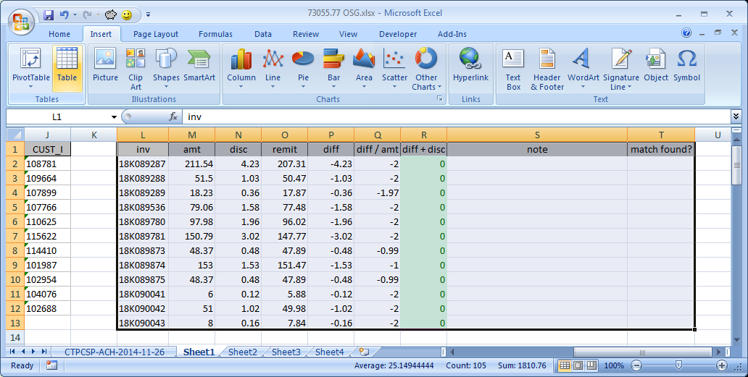
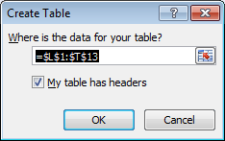
Part 2: Analysis of the short/overpays:
- Rows that have green coloring on the diff+disc column (column R), means that the amount + discount that the system has is perfect and should be left alone. THIS IS A GOOD THING (if you F6 out of the batch and go back in, some discounts may be removed or invoices might be out of order compared to how they were selected! Be careful if you do this. You might want to just run the macro again if you did this after deselecting everything.)

- If diff+disc is NOT zero, but diff/amt is close to 1% or 2%, but it’s a few pennies off, this usually means that the invoice probably calculated the discount WITH the freight/tax amount, so you can change the discount to the proper amount. ONLY DO THIS IS YOUR DIFF/AMT IS CLOSE TO A FULL % NUMBER LIKE 1.97 MEANS IT’S TWO PERCENT DISCOUNT, 0.98 MEANS 1 PERCENT DISCOUNT. (there is an example of this. Example 2)

- Read the note column to see if there are notes available on why diff+disc is not zero. Sometimes it says something like “short paid by 50” or “short paid tax” or “including credit invoice 123456789”. Sometimes they list the credit, sometimes they don’t. IF THEY DON’T: do iq76 on the invoice, then do iq52 on the customer number and check the account for matching credits. There is a good chance you will find your difference on a credit on the account. Sometimes there are two credits that add up to the short pay, but don’t spend too much time if there are a lot of credits. If you can’t figure it out in a minute, just short pay the invoice and make sure to remove any discount amount. (Example 1 shows this)

Examples:
EXAMPLE 1: Short paid invoice is actually on the account. It has a note, but it doesn’t help this time.
Short paid invoice 21k016347 is actually a credit on the account:
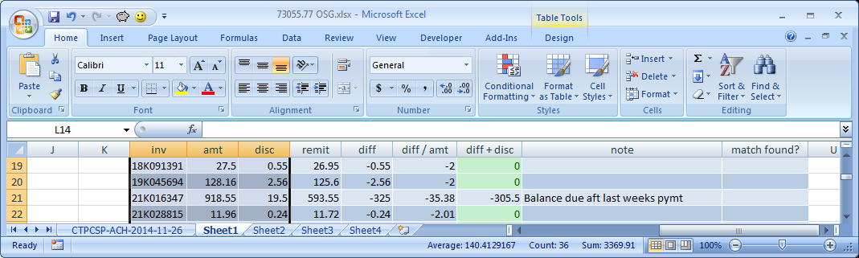
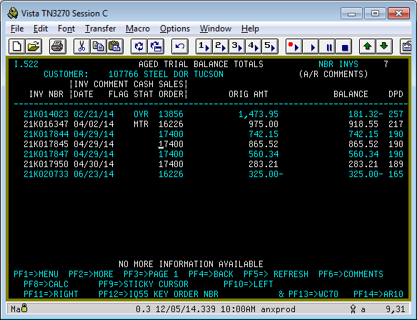
So to solve this invoice’s difference, you have to remove the discount on the invoice, and pull in that credit on the account. SOMETIMES YOU WILL SEE A MATCHING CREDIT FOR AN AMOUNT ON DIFF+DISC INSTEAD OF THE DIFF COLUMN. THIS MEANS THAT THE CUSTOMER IS USING A CREDIT ON THE ACCOUNT, BUT IS ALSO KEEPING THE DISCOUNT ON THE ORIGINAL INVOICE AMOUNT IN THE SYSTEM. IN THIS CASE, KEEP THE DISCOUNT ON THE INVOICE BEING SHORT PAID, BUT ALSO PULL THE CREDIT INVOICE.
Example 2: Short paid invoices is actually counting the freight/tax as part of the discount. The discount should be adjusted by that small difference. THIS IS OK BECAUSE THE DIFF/AMT COLUMN IS CLOSE TO OR MATCHES A WHOLE NUMBER 1 OR 2:
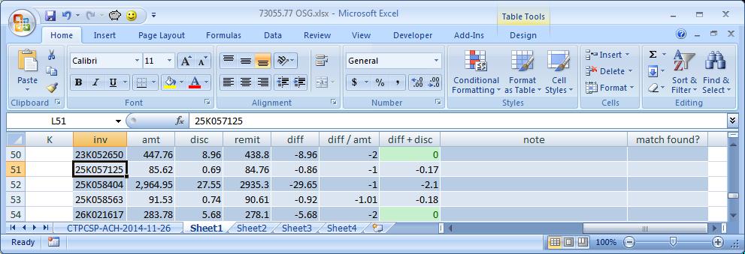
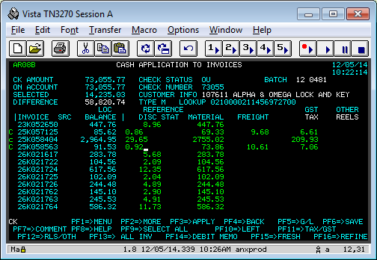

The amounts listed under diff go in the discount column as a positive amount if they are negative on the diff column. You will see this small difference often when there is a freight or tax on the invoice.

Example 3: Invoice is being overpaid but iq76 shows that the original invoice amount matches the remittance:
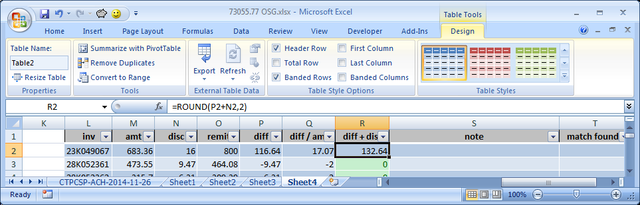
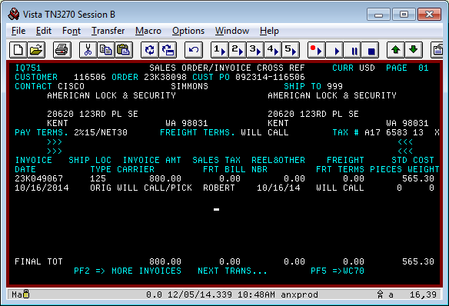
In this case, just ar21 the invoice, and readjust the invoice based on the ar21 history to match the remittance amount.

Example 4: Short pay is freight/tax.
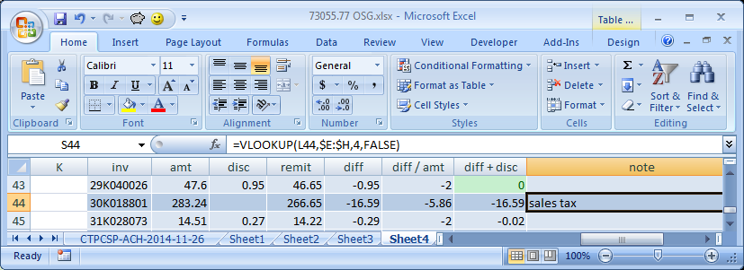Sometimes the note says to deduct sales tax like it does here, other times it will just be the exact difference that you are seeing on the diff column.

- After you finish with all your selected invoices and adjustments, your selected amount should match the column F Sum amount on that tab (you will have to add the sum equation there):
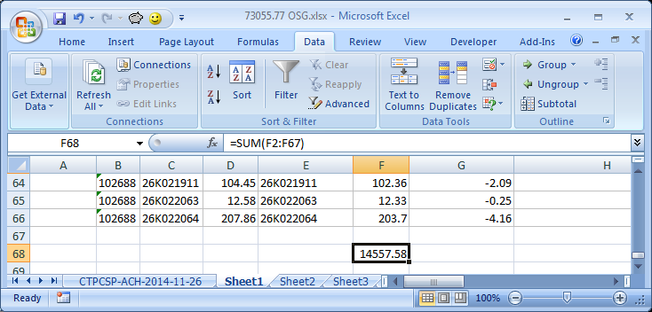
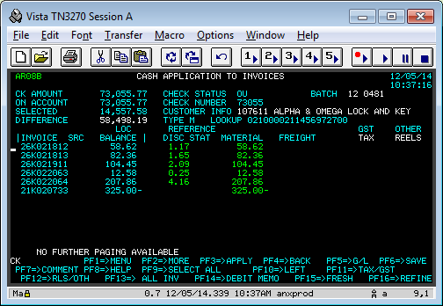

- Partially apply, then move on to the next tab and start again.

- The tab where you copied over all the short/over pay invoices that were zero is the easy part. You just have to remove discount on all the invoices after you run the macro to select them. That should match your amount and you can partially apply the last amount on the payment. Remember that you still have to limit the customer number count to about 11 or 12 before running the macro, so follow the steps above to separate the sheet if you have to (you usually will have to with OSG)

